INNOLOFT VENTURES | InnoTrack Daily Report | 20-Day Internship Program

DAILY INTERNSHIP REPORT
Submit this report on InnoTrack by 5:00 PM every day
SECTION 1 — STUDENT INFORMATION

Student Name | Nareddy.Shanmukha NihalReddy | VTU ID | 28683
Branch / Dept. | CSE(AI&DS) | Internship Day No. | 2
Date | 02/06/2026 | Track (1 / 2 / 3 / 4) | 1
Project Title | Customer Churn Prediction System - E-commerce | Mentor Name | JAYASRI

SECTION 2 — WHAT DID YOU LEARN TODAY?

Topic / Concept Learned
TOPIC:Functions, Conditional Statements, Loops, User Input, Lists, List Operations, Grade Calculation, Multiplication Tables, ATM Login System, Even-Odd Number Sorting
CONCEPTS LEARNED: Function Definition & Calling, If-Else Logic, For & While Loops, Return Statements, Modulus Operator, List Appending, Counter Variables, Input/Output Operations, Decision Making, Repetition, Authentication Logic, Data Storage using Lists, Basic Algorithm Design, Problem Solving using Python
Introduction to Git & GitHub, creating repositories, understanding Git workflow, and adding/editing a README file in GitHub.

SECTION 3 — WHAT DID YOU BUILD TODAY?

Code / Output / Feature Built
Grade Calculator:
def grade(marks):

if marks>=90:
return 'A'
elif marks>=75:
return 'B'
elif marks>=60:
return 'C'
elif marks>=45:
return 'D'
else:
return 'F'
for i in range(5):
marks=int(input("Enter marks:"))
print("grade",grade(marks))
OUTPUT:
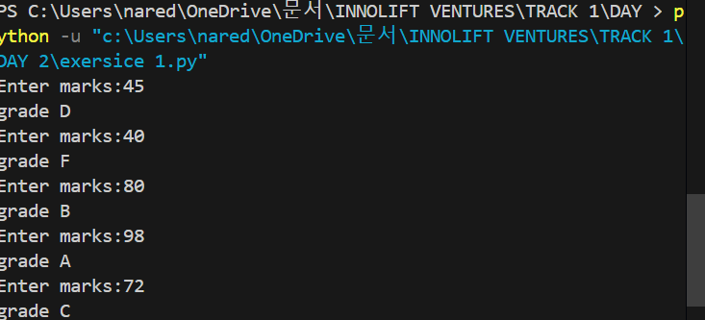

FEATURE BUILT:
Developed an automated student grading system using functions and conditional statements.

Implemented user input handling and grade assignment for multiple students using loops.

Multiplication Table Generator:
def times_table(n):
for i in range(1, 11):
print(n, "x", i, "=", n * i)

for i in range(3):
num = int(input("Enter a number: "))
times_table(num)
print()
OUTPUT:
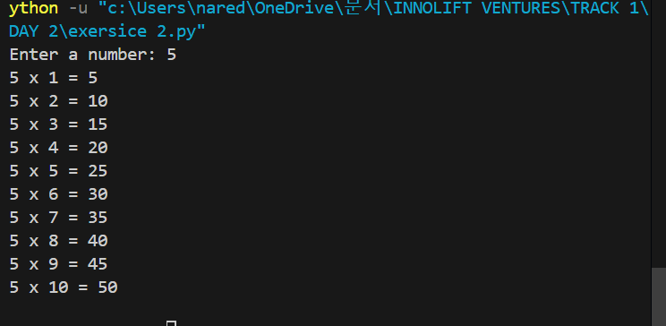

FEATURE BUILT:
Developed a multiplication table generator using functions and loops.
Implemented user input support to generate multiplication tables for multiple numbers automatically.

ATM PIN Checker:
correct_pin = 1234
attempts = 0

while attempts < 3:
pin = int(input("Enter PIN: "))

if pin == correct_pin:
print("Access Granted")
break
else:
print("Wrong PIN")
attempts += 1

if attempts == 3:
print("Card Blocked")
OUTPUT:
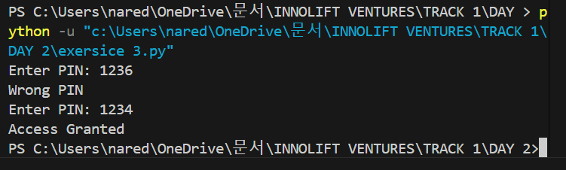
FEATURE BUILT:
Developed a secure ATM PIN verification system with user authentication.

Implemented login attempt tracking and automatic card blocking after three incorrect PIN entries.

Even / Odd Sorter:
def sort_numbers(numbers):
even = []
odd = []

for num in numbers:
if num % 2 == 0:
even.append(num)
else:
odd.append(num)

return even, odd

numbers = []

for i in range(10):
num = int(input(f"Enter number {i+1}: "))
numbers.append(num)

even_numbers, odd_numbers = sort_numbers(numbers)

print("Even Numbers:", even_numbers)
print("Odd Numbers:", odd_numbers)
OUTPUT:
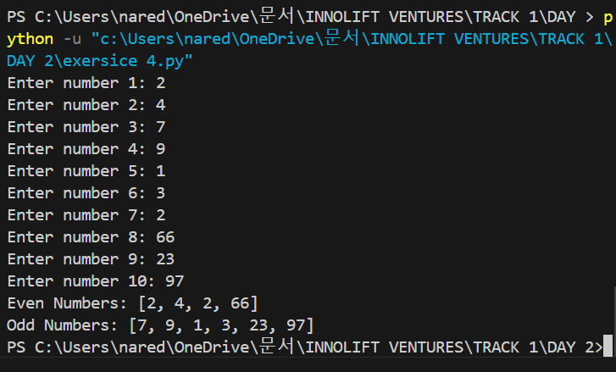
FEATURE BUILT:
Developed a number classification system to separate even and odd numbers using functions and lists.

Implemented user input collection, list processing, and automatic categorization of numbers into even and odd groups.

SECTION 4 — PROBLEMS FACED & HOW YOU SOLVED THEM

Error / Problem
Faced issues in understanding function parameters and using return statements correctly.
Initially had difficulty calling the function repeatedly for multiple user inputs.
Encountered challenges in managing login attempts and controlling loop termination after successful authentication
Faced confusion in storing user inputs in lists and separating numbers using conditional logic.
How I Fixed It
Reviewed function structure and used return correctly to send grades back to the main program.
Used a for loop to repeatedly call the function for different user-entered numbers.
Implemented a counter variable and used break to exit the loop when the correct PIN was entered.
Used lists with the append() method and applied the modulus (%) operator to classify numbers correctly.

SECTION 5 — PLAN FOR TOMORROW

What will you do tomorrow?
Learn NumPy fundamentals including arrays, indexing, slicing, mathematical operations, and data manipulation techniques.

Explore Pandas concepts such as Series, DataFrames, data loading, filtering, cleaning, and basic analysis using real-world datasets.

SECTION 6 — LINKS & ATTACHMENTS

GitHub Repo / Commit Link | https://github.com/NSNihalreddy/VELTECH-SUMMER-INTERNSHIP-/tree/main/Innolift%20Ventures/Track%201/DAY%202
Model Result / Colab Link | All Day 2 exercises were completed successfully and uploaded to GitHub with the required folder structure.
Deployed App Link (if any) | NA
Additional Notes | Successfully completed Python exercises using functions, loops, and conditional statements.  Gained practical experience in problem-solving and program logic development.  Learned basic GitHub operations, including repository organization and README file management.

SECTION 7 — SELF RATING FOR TODAY

Area | 1 | 2 | 3 | 4 | 5
Understanding of today's concept | ☐ 1 | ☐ 2 | ☐ 3 | ☐ 4 | ☑ 5
Hands-on coding confidence | ☐ 1 | ☐ 2 | ☐ 3 | ☐ 4 | ☑ 5
Progress on my project | ☐ 1 | ☐ 2 | ☐ 3 | ☑ 4 | ☐ 5
Overall satisfaction with today | ☐ 1 | ☐ 2 | ☐ 3 | ☐ 4 | ☑ 5

Case Study: Customer Churn Prediction System - E-commerce
Project Overview
The Customer Churn Prediction System is designed to identify customers who are likely to stop using an e-commerce platform. By predicting churn early, businesses can take steps to retain valuable customers and improve customer satisfaction.
1. What Problem Does the Project Solve?
Many e-commerce companies lose customers over time due to poor engagement, pricing issues, or better offers from competitors. Losing customers affects revenue and business growth.
This project helps predict which customers are likely to leave so that the company can take preventive actions and improve retention.
2. Who Are the End Users?
- E-commerce business owners
- Marketing teams
- Customer retention teams
- Sales managers
These users can use the prediction results to identify high-risk customers and provide special offers or support.
3. What Dataset Will Be Used and Why?
We will use the Telco Customer Churn Dataset.
Reasons:
- Contains customer details and churn information.
- Suitable for classification problems.
- Widely used for learning customer churn prediction.
- Includes useful features such as tenure, contract type, monthly charges, and payment methods.
4. How Will the Dataset Be Collected?
The dataset will be downloaded from publicly available sources such as:
- Kaggle
- IBM Sample Datasets
After downloading, the data will be cleaned and prepared for machine learning.
5. What Machine Learning Approach Will Be Followed?
The project will use a supervised machine learning approach because the dataset contains known churn labels.
Steps:
- Perform Exploratory Data Analysis (EDA).
- Handle missing values and encode categorical data.
- Train a Gradient Boosting model.
- Evaluate model performance.
- Generate churn probability scores.
- Save the trained model as a .pkl file for deployment.
6. What Will the Final Web App Look Like?
The web application will be developed using Flask.
Features:
- User enters customer information through a form.
- System predicts churn probability.
- Displays customer risk level.
- Shows top reasons for possible churn.
- Provides retention recommendations.
- Simple and user-friendly interface.
Expected Outcome
The system will help businesses identify customers who may leave and support decision-making for customer retention strategies.

